How We Age
From DNA damage to cellular miscommunication, aging is a mysterious and multifarious process.
By The Scientist Staff | March 1, 2015

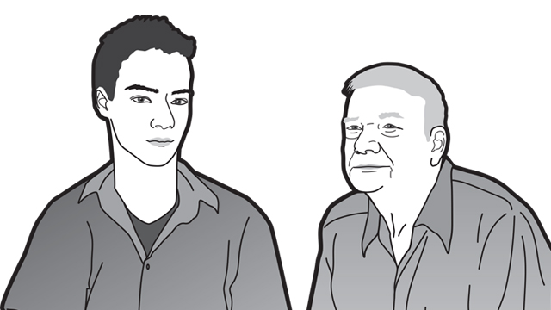

Growing old is a fact of life. And there’s no mistaking it, given the increased fatigue, weakened bones, and ill health that generally accompany aging. Indeed, age is the number one risk factor for myriad diseases, including Alzheimer’s, cancer, cataracts, and macular degeneration. And while researchers are making progress in understanding and treating each of these ailments, huge gaps remain in our understanding of the aging process itself.
“We age so completely and in so many different ways,” says stem cell biologist Derrick Rossi of Harvard University. “We are programmed to die.”
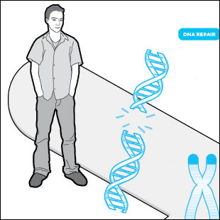
AS TIME GOES BY: Aging is the outcome of diverse and complex changes in normal biological functions, from the accumulation of DNA damage to dysfunction of proteins and altered communication both within cells and among distant tissues in the body. Researchers are beginning to piece together how we age at the level of our genomes, our cells, and our whole bodies, in hopes of identifying strategies for slowing decline and extending healthy life span.
See full infographic: JPG | PDF© TAMI TOLPAThe aging process can be traced down to the level of cells, which themselves die or enter senescence as they age, and even to the genomic level. Accumulation of mutations and impairments in DNA repair processes are highly associated with symptoms of aging. In fact, disorders that cause premature aging are typically caused by mutations in genes involved in the maintenance of our DNA. And at the cellular level, decreases in stem cells’ proliferative abilities, impairments in mitochondrial function, and proneness to protein misfolding can all contribute to aging. As scientists continue to detail these various processes, says Paul Robbins of the Scripps Research Institute, “the big question is, ‘At what step along all these pathways is the best place to intervene to try to promote healthy aging?’”
While diverse strategies—from caloric restriction to genetic manipulation—have proven to extend life span in model organisms in the lab, these animals are not necessarily enjoying longer periods of health. (See “Quantity or Quality?”) In the end, researchers studying aging must learn not just how to extend life, but how to prevent age-related disease and physical decline.
“The [therapeutic] goal would be to increase health span, not life span,” says Rossi. “There’s nothing fun about living to be really old if your health diminishes to the point that it’s no longer fun to be alive.”

Damage control
As DNA replicates, the cellular machinery involved in the process makes mistakes, leading to changes in the DNA sequence. Mutagens such as reactive oxygen species (ROS) or UV radiation can also damage DNA. Most of the time, DNA repair mechanisms fix the damage, but errors slip through and accumulate as an organism ages. Aging has also been linked to the deterioration of DNA repair machinery, allowing permanent errors to become more common in older organisms.
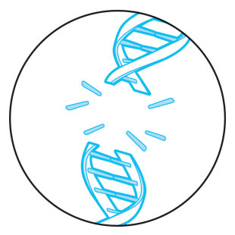© TAMI TOLPAOnce DNA has become too damaged, cells kill themselves or enter a nonreplicating state, a process called senescence. Loss of cells can lead to tissue atrophy and dysfunction. And senescent cells, though largely dormant, may actually speed the aging process by secreting inflammatory cytokines thought to contribute to atherosclerosis and other aging-related diseases. Additionally, DNA scaffolding proteins that typically help stabilize the genome show changes with age, contributing to impaired cell division, increased senescence, and other aging-related processes.
While it’s unclear exactly how DNA damage contributes to aging, what’s certain is that the damage and mutations contribute to cancer, says Jan Vijg, a geneticist at Albert Einstein College of Medicine in New York City. “There is this exponential increase in cancer risk during aging, so it’s not at all unlikely . . . that accumulation of damage to the genome is really a major factor here,” he says.
Premature-aging diseases in humans also point to the role of DNA repair and stabilization mechanisms in the aging process. For instance, people with Hutchinson-Gilford progeria syndrome have mutations in a gene encoding scaffolding proteins called nuclear lamins and suffer from hair loss, an aged appearance, vision deterioration, and atherosclerosis as children. In another example, Werner syndrome patients, who develop symptoms of advanced aging as teenagers, have mutations in a gene involved in DNA repair. (See “Nourishing the Aging Brain.”)
Aging has been linked to the deterioration of DNA repair machinery, allowing permanent errors to become more common in older organisms.
But how DNA damage leads to aging in normal adults remains an open question. “We have beautiful next-generation sequencing methods, and we can sequence the DNA that we isolate from a tissue. But that will not help us a lot because mutations are random, and they will be different from cell to cell,” says Vijg, who is now trying to understand how such mosaics of cells work together to cause aging. —Kate Yandell

Epigenetic shifts
In the early 1990s, Jean-Pierre Issa, then at Johns Hopkins University, was studying changes in DNA methylation in colon cancer cells when he noticed that the epigenetic marks were shifting over time—not just in tumor cells, but also, to a lesser degree, in a variety of healthy cells. Indeed, mapping of DNA methylation in human cells has shown that some areas of the genome become hypermethylated with age, while others show reduced methylation. Histone modifications, another type of epigenetic mark, have also been shown to change with age in some human tissues.
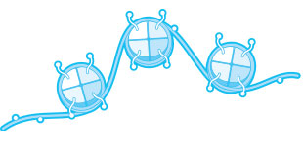© TAMI TOLPAThese changes happen through mistakes during the processes of replication or DNA damage repair. During replication, DNA methylation and histone modifications are not always perfectly reproduced. When DNA is damaged, repair proteins must often remove epigenetic marks to access the damaged genetic material and repair it. Epigenetic marks can then be omitted or replaced incorrectly.
The question now is whether these epigenetic changes influence aging. “Is this an epiphenomenon that happens just because we age, or is it actually causing symptoms or diseases of aging and limiting life span?” says Issa, who now studies the epigenetics of cancer and aging at Temple University in Philadelphia, Pennsylvania.
Epigenetic changes are known to contribute to cancer, and there is intriguing evidence from animal models that changes to histone modifications do affect aging. For instance, inhibiting a histone demethylase enzyme extends life span in Caenorhabditis elegans (Cell Metab, 14:161-72, 2011), while alterations to proteins involved in methylating histones leads to longer-lived flies (PNAS, 107:169-74, 2010) and worms (Nature, 466:383-87, 2010). Similarly, altering acetylation can affect life span in yeast. (See “Weiwei Dang: Epigenetics in Aging.”) Issa is currently searching for drugs that can modulate DNA methylation in cancer and hopes they may one day slow aging.
But DNA methylation changes with age are not uniform, he notes. “We gain at some sites, and we lose at other sites,” Issa says. Simply deleting or overexpressing methyltransferases will be insufficient to recapitulate the methylation patterns of youth. —Kate Yandell

Telomere trouble
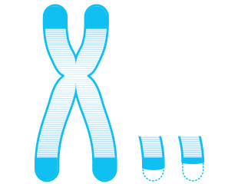© TAMI TOLPAA particularly influential form of DNA damage occurs at telomeres, the repetitive sequences that cap chromosomes and shorten with age. While germ and stem cells express an enzyme called telomerase that replenishes telomeres, most cells’ telomeres shrink with every division, due to the fact that DNA polymerase cannot fully replicate the ends of chromosomes. If the telomeres shrink too much or are damaged, cells undergo apoptosis or enter senescence.
Telomere damage has clear effects on aging. Mice with short telomeres have diminished life spans and reduced stem-cell and organ function, while mice whose telomerase is enhanced in adulthood age more slowly (EMBO Mol Med, 4:691-704, 2012). In humans, mutated telomerase is associated with disorders involving organ dysfunction and elevated cancer risk (J Clin Invest, 123:996-1002, 2013).
In recent years, researchers have also shown that telomeres are targets of stress-induced DNA damage (Nat Comm, 3:708, 2012). “For reasons we don’t really understand yet, they are very sensitive to external stress, more than the rest of the genome,” says João Passos, a researcher at Newcastle University’s Institute for Ageing in the U.K.
Once telomeres have been damaged, they are difficult to repair. They protect chromosomes from fusing with one another by recruiting protein complexes called shelterins that prevent overzealous DNA repair proteins from mistaking loose ends for double-strand breaks. This may also prevent repair proteins from accessing legitimate DNA damage, however, leading to cell death or senescence.
Telomeres may be especially prone to DNA damage in order to protect the body from cancer, Passos suggests. Because they are disproportionately damaged by stressors, and because telomere damage so often leads to senescence, they could be like canaries in coal mines, warning cells that carcinogens are present. Telomeres may, in fact, be DNA-damage sensors that shut down cell proliferation in times of stress, Passos says. This is a double-edged sword, as senescence lowers cancer risk but also leads to symptoms of aging. —Kate Yandell

In the folds
Life depends on proper protein function. And proper protein function is all about proper protein folding. Misshapen proteins are often rendered useless and can clump together with other misfolded proteins inside cells. It is not yet clear whether protein misfolding leads to aging, but it appears that it is an almost inevitable physiological reality that the two coincide. To add insult to injury, advancing age also brings about the decline of molecular chaperones that aid in the folding process and of protective pathways that normally help clear misfolded proteins from cells.
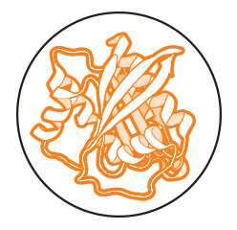© TAMI TOLPA“The big open question is whether the accumulation of misfolded protein aggregates is the cause or consequence of the aging process,” says Claudio Soto, a neuroscientist at the University of Texas Health Science Center at Houston who studies the effects of misfolded protein aggregations in the brain. “The hypothesis is that maybe there is a widespread accumulation of misfolded protein aggregates affecting all cells in the body, and that produces progressive dysfunction of cells in the body that leads to aging.”
The model organism C. elegans has yielded tantalizing clues that may help answer the chicken-or-egg question regarding protein misfolding and aging. Northwestern University molecular biologist Richard Morimoto and colleagues showed that the worm’s proteostasis machinery, which includes molecular chaperones, stress-response transcription factors, and protein-degrading enzymes, starts breaking down very early on in the animal’s three-week life span (PNAS, 106:14914-19, 2009). “What’s interesting is that this happens very early in adulthood,” Morimoto says. “You see these changes within days of becoming an adult.”
Soto says that problems with protein folding might be central to the multitude of molecular deficiencies that characterize an aging body. After all, normal protein folding is necessary for gene expression, enzyme function, and a host of other crucial physiological events. “This could actually unify the different processes,” he says.
And if protein misfolding does act as a sort of linchpin in aging, correcting it may be a way of staving off a host of age-related maladies or even aging itself, Soto adds. “The good news is that, if that’s the case, you could envision really intervening in this and delaying the aging process.” —Bob Grant

The Goldilocks Organelle
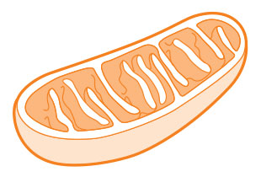© TAMI TOLPAThe free-radical theory of aging, developed in the 1950s, proposes that reactive oxygen species (ROS) cause aging by wreaking global cellular damage. As one of the major sources of ROS, mitochondria—and, specifically, ROS injuries to these organelles and their DNA—are presumed to also play a role in aging. “It’s one of the robust theories of aging,” says Gerald Shadel, who studies mitochondria at Yale University. Often, he says, it’s what comes to mind first when people think of the molecular and cellular mechanisms of aging. And while there is some evidence supporting it, “there’s now a lot of evidence against that concept.”
Beginning in the 1990s, scientists studying model organisms observed phenomena that contradicted the free radical theory. For instance, enzymes that block the production of ROS didn’t extend the life span of mice; in worms, stressing the mitochondria at a certain stage of development actually increased life span; and, as Shadel’s group showed in 2011, ramping up mitochondrial ROS extended longevity in yeast (Cell Metab, 13:668-78, 2011). “It looks like ROS signaling is important for normal physiology,” says Shadel.
Such evidence is helping to shape a new view of oxidative damage to mitochondria. “If damage is not too severe, there’s some sort of protective response,” says Toren Finkel, an aging researcher at the National Heart, Lung, and Blood Institute. “What won’t kill you makes you stronger.”
There is a limit to how much damage the organelle can handle, however, and mitochondrial dysfunction may well contribute to aging. Recent evidence in mice shows that mutations in mitochondrial DNA are linked with shortened life span (Sci Rep, 4:6569, 2014). “It’s consistent with this idea that maybe from metabolism you get oxidative stress, you then get DNA damage, then that decline in mitochondrial function makes us age,” says Finkel. “I think there’s still a lot to that [idea].”
Beginning in the 1990s, scientists studying model organisms observed phenomena that contradicted the free radical theory.
Shadel says mitochondria’s role in aging is likely not limited to ROS or even DNA damage. Given the organelles’ broad-reaching involvement in metabolism, inflammation, and epigenetic regulation of nuclear DNA, Shadel says, “I think they’re central integrators of many of the pathways we’ve implicated in aging.” —Kerry Grens

Stem cells
Healthy adults produce about 200 billion new red blood cells each day to replace the same number removed from circulation every 24 hours. But the rate of blood-cell production declines with age. For this and other reasons, around 10 percent of people age 65 and older are anemic. Scientists are now homing in on how hematopoietic stem cells (HSCs) and other stem-cell populations show reduced regenerative capacity with age. (See “In Old Blood,” The Scientist, August 2014.)
“It’s a bit of a mystery as to why these self-renewing cells in different tissues stop working,” says geneticist Norman Sharpless from the University of North Carolina at Chapel Hill School of Medicine. “The nature of molecular aging at the cellular level is not fully known.”
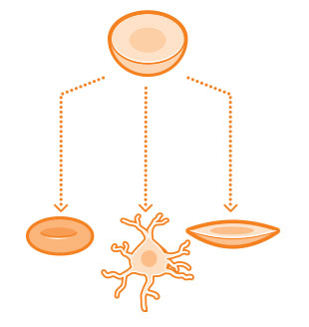© TAMI TOLPAWhile HSCs remain dormant, or quiescent, for extended periods of time, they remain vulnerable to DNA damage. And during these periods of dormancy in mouse HSCs, DNA damage response and repair pathways weaken, Harvard’s Derrick Rossi and his colleagues reported recently (Cell Stem Cell, 15:37-50, 2014). This reduced capacity for DNA damage repair can let harmful mutations linger. “What we found is that this [cellular] life of luxury on the couch is about as detrimental to the health of an HSC as life perpetually spent on the couch [is to] humans,” Rossi says.
Researchers have also linked epigenetic alterations, such as locus-specific changes in DNA methylation, to the reduced regenerative capacity of stem cells with age. And age-related shifts in the environment in which stem cells divide and differentiate, dubbed the stem-cell niche, may also contribute to stem-cell aging. For example, as Hartmut Geiger of the University of Ulm, Germany, and his colleagues showed in 2012, age-related changes in supportive niche cells influence hematopoietic progenitor cell populations: young microenvironments fostered more homogeneous groups of cells as compared with aged ones (PLOS ONE, doi:10.1371/journal.pone.0042080, 2012).
Exactly why and how stem cells slow down with age is still a mystery. “Everybody’s got a favorite theory,” says Sharpless, but “it’s sort of an open question.” —Tracy Vence

Cell talk
Stem cells and other cells that undergo damage and decline do not age in isolation. Researchers are finding that some processes of aging influence the release of regulators that circulate in the blood. “At one time, everybody thought, well, cells just get old and die,” says Paul Robbins of the Scripps Research Institute. “But the cells do more than just die. They do negative things, and they persist.”
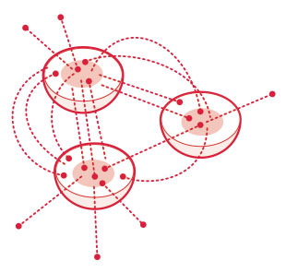© TAMI TOLPAOne such regulator is growth differentiation factor 11 (GDF11), which controls the gene expression patterns that set up front-to-back orientation in mammalian embryos and measurably decreases with age. Recently, a team of Harvard Medical School researchers surgically joined young and old mice—a classical technique called parabiosis—to investigate the roles of blood-borne factors in aging. Amy Wagers, Richard Lee, and their colleagues found that young blood can restore some lost functions in the hearts, brains, and skeletal muscles of older mice, and that these effects can be replicated by treating old mice with GDF11 (Cell, 153:828-39, 2013; Science, 344:630-34; 344:649-52, 2014).
The researchers are now working to pinpoint the sources of circulating GDF11, as well as to understand the mechanisms by which it remodels aging tissues. Another important question is “how consistent this is across mammals,” says Lee, “because then these things that we do in mice might become more relevant to humans.”
The team is collecting blood samples from mammals of different ages—“everything from cats to cows” and other farm animals, says Lee—to examine their GDF11 levels. They also hope to develop a more sensitive method to measure the protein in humans, in order to test associations between GDF11 levels and aging-related diseases.
Other scientists are focusing on the transcription factor NF-κB, a central activator of inflammation, as a driver of aging. Overactivation of NF-κB may cause senescent cells to release cytokines that stimulate inflammation and lead to further degeneration, even in far-flung parts of the body. “It seems that with almost anything that activates NF-κB, if you reduce it, it improves aging,” says Robbins. He and his colleagues have demonstrated that inhibiting NF-κB can stave off cell senescence in mice that age prematurely due to DNA repair defects (J Clin Invest, 122:2601-12, 2012). “[We want] to see if we can understand the contribution of what goes on within a cell versus the contribution of what that cell secretes that affects cells at a distance,” he says. —Molly Sharlach
Correction (March 2): This story has been updated to correctly identify Norman Sharpless as a geneticist, not a clinical geneticist. The Scientist regrets the error.

